1. Cube series without using power maths function. (Use For loop)

**SOLUTION:**

for (int i = 1; i <= 10; i++)

{

Console.WriteLine("number is {0} and the cube of {1} is {2}", i, i, i * i * i);

}

**OUTPUT:**

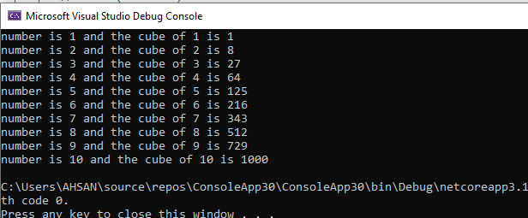

1. Square Series without using power maths function (use For loop)

**SOLUTION:**

for (int i = 1; i <= 10; i++)

{

Console.WriteLine("number is {0} and the square of {1} is {2}", i, i, i * i);

}

**OUTPUT:** 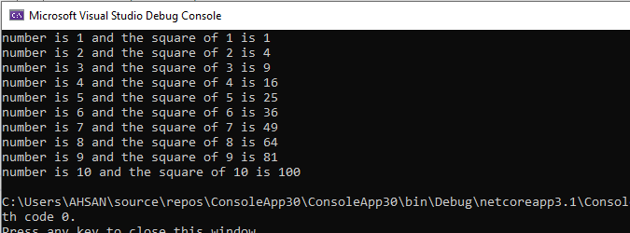

1. Repeatedly print the value of the variable xValue, decreasing it by 0.5 each time, as long as xValue remains positive.

**SOLUTION:**

for (double i = 6; i >= 0; i -= 0.5)

{

Console.WriteLine(i);

}

**OUTPUT:** 

1. Print the square roots of the first 25 odd positive integers.

**SOLUTION:**

for (int i = 1; i <= 50; i += 2)

{

double x = Math.Pow(i, 0.5);

Console.WriteLine("number is {0} and square root is {1}", i, x);

}

**OUTPUT:**

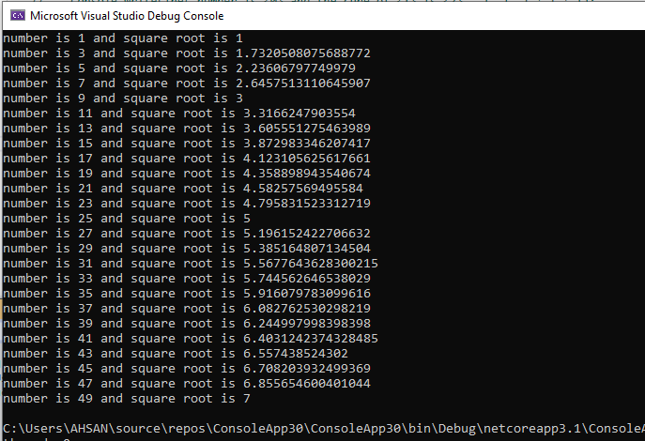

1. Make a game in C#, in which give 5 tries to the user to guess the value of the number.

**SOLUTION:**

Console.WriteLine("--*****you have total 5 tries guess any numbers*****--");

const double num = 1234;

for (int i = 1; i <= 5; i++)

{

Console.Write("\nyour {0} try guess the number= ", i);

int num1 = int.Parse(Console.ReadLine());

if (num1 == num)

{

Console.WriteLine("-----congrats your number matched to our secret number-----");

}

else

{

Console.WriteLine("-----your number not matched to our secret number-----");

}

}

**OUTPUT:** 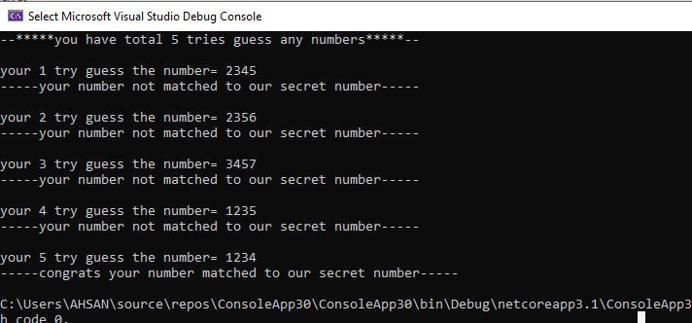

1. Generate Stars using 2 for loops

*  
**  
***  
****  
*****  
******

**SOLUTION:**

for (int i = 0; i <= 7; i++)

{

for (int x = 0; x < i; x++)

{

Console.Write("* ");

}

Console.WriteLine();

}

for (int row = 7; row > 0; row--)

{

for (int col = 0; col < row; col++)

{

Console.Write("* ");

}

Console.WriteLine("");

}

**OUTPUT:**

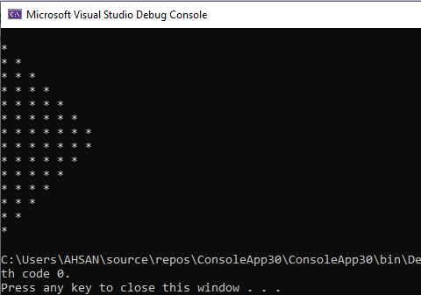

1. Write a program that reads from the console a positive integer number N (N < 20) and prints a matrix of numbers as on the figures below:

**N = 3 N = 4**

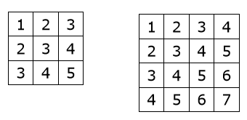

**SOLUTION:**

int k = 1;

for (int row = 0; row < 3; row++)

{

for (int col = 0; col < 3; col++)

{

Console.Write(k + " ");

k++;

}

k -= 2;

Console.WriteLine(" ");

}

**OUTPUT:**

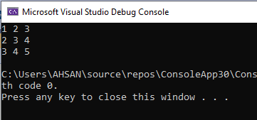

**SOLUTION:**

int k = 1;

for (int row = 0; row < 4; row++)

{

for (int col = 0; col < 4; col++)

{

Console.Write(k + " ");

k++;

}

k -= 3;

Console.WriteLine(" ");

}

**OUTPUT:**

